Correlation coefficient
Pearson sample correlation coefficient (r)
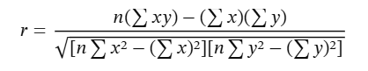

- Calculate Numerator
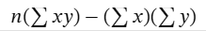

- Calculate Denominator
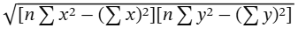

- Divide Numerator by denominator to calculate (r)


- Will calculate the (r) for 3 students with number of studied hours with test scores

(x) (hours studied): 2, 4, 6
(y) (test score): 3, 7, 10

Output | Processes | Inputs / Data | Steps /algorithm
 |  | x,y,n,Xy, totalX, totalY, xPow, yPow, a. b. r | Reserve place in memory  x For no. of hours  y For test scores  n Length of arr  i Index of arr  Sum x Sum of x values  Sum y Sum of y values  Sum xy Sum of x * y  Sum x² Sum of x square  Sum y² Sum of y square  a Numerator  b Denominator  r Correlation coefficient
 | $$\sum_{x=0}^{n}{x}$$ |  | Calculate sum of x
 | $$\sum_{y=0}^{n}{y}$$ |  | Calculate sum of y
 | $$\sum_{xy=0}^{n}{xy}$$ |  | Calculate Sum xy
 |  |  | Calculate a numerator a
 | $$\sum_{x=0}^{n}{x²}$$ |  | Calculate Sum x²
 | $$\sum_{y=0}^{n}{y²}$$ |  | Calculate Sum y²
 |  |  | Calculate Denominator b
 | a/b |  | Calculate (r)
r |  |  | Print (r)

